CI/CD (Continuous Integration and Continuous Delivery/Deployment) is a modern software development practice that automates the process of building, testing, and releasing applications. It plays a key role in DevOps by streamlining collaboration between development and operations teams.
- Automates code integration, testing, and deployment workflows.
- Reduces manual effort while improving software quality.
- Smaller, frequent updates replace large risky releases.

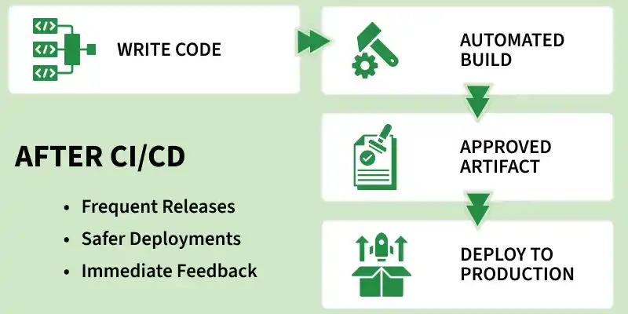

Continuous Integration (CI)
Continuous Integration focuses on integrating code changes frequently to avoid conflicts and ensure code stability.
- Goal: Prevent “integration hell” caused by late code merging.
- Process: Developers merge code changes into the main branch frequently (often daily).
- Automation: Each commit triggers an automated build and unit tests.
- Outcome: If tests fail, the build is rejected and developers are notified immediately

Continuous Deployment (CD)
Continuous Deployment takes automation a step further by removing manual intervention in releases.
- Goal: Enable fully automated and faster production releases.
- Process: After all tests pass, code is automatically deployed to production.
- Automation: End-to-end pipeline runs without human involvement.
- Requirement: Requires highly reliable and comprehensive automated testing.

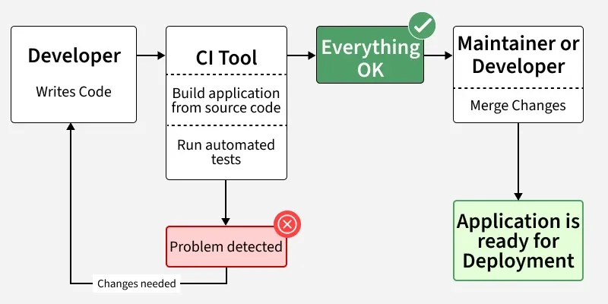

CI/CD Pipeline
A CI/CD pipeline is an automated workflow that enables teams to build, test, and deploy code efficiently and reliably.
In simple terms, it is a series of automated steps that help deliver software faster with fewer errors.
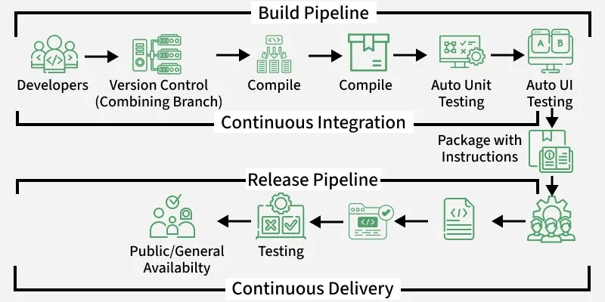
- Developers push code to version control.
- Code is compiled and built.
- Automated testing is performed.
- Application is packaged.
- Code moves through release pipeline.
- Delivered to users after validation.

Advantages of CI/CD:
Beyond the core benefits of speed and code quality, implementing CI/CD pipelines offers significant advantages in business agility, security, and team culture. Here are several additional benefits:

1. Enhanced Security (DevSecOps)
Modern CI/CD pipelines allow you to "shift security left." Instead of treating security as a final check, you can integrate automated tools directly into the pipeline:
- Vulnerability Scanning: Automatically check third-party libraries and dependencies for known security flaws during every build.
- Static/Dynamic Analysis: Run automated security code reviews to identify patterns that could lead to exploits before the code is even merged.
- Compliance Automation: Enforce configuration policies and regulatory standards automatically, ensuring every deployment is compliant.

2. Business Agility and Market Responsiveness
CI/CD shifts the focus from "project delivery" to "continuous value delivery":
- Rapid Experimentation: With the ability to deploy safely and quickly, businesses can run A/B tests or canary releases to see how real users interact with new features before a full rollout.
- Faster Response to Market Shifts: If a competitor releases a new feature or a critical market trend emerges, a CI/CD-enabled team can pivot and deploy a response in hours or days, rather than months.
- Minimized "Mean Time to Recovery" (MTTR): Because the pipeline is automated, if a failure occurs in production, rolling back to the previous stable state is often just a matter of re-running the pipeline for a previous commit.

3. Cultural and Organizational Benefits
The transition to CI/CD often acts as a catalyst for a healthier engineering culture:
- Shared Accountability: Since the entire team can see the status of the pipeline (green for success, red for failure), quality becomes everyone's responsibility, not just the QA team’s.
- Reduced "Hero Culture": By automating the "toil" of deployments, you remove the reliance on specific "release managers" or "key people" who know how to manually deploy the application. The system handles it, making releases boring and routine.
- Continuous Learning: The short feedback loops mean developers learn from their mistakes immediately. They spend less time debugging ancient, stale code and more time learning how their specific changes impact the system in real-time.

4. Better Infrastructure Management
- Infrastructure as Code (IaC): CI/CD pipelines often include the deployment of infrastructure (servers, databases, networking) alongside the application code. This ensures that the environment the application runs in is as version-controlled and reliable as the application itself.
- Consistent Environments: By using containers (like Docker) and automated provisioning, you eliminate the "it works on my machine" problem, as the test, staging, and production environments are fundamentally identical.

Summary of Advanced Advantages
Category | Key Benefit
Security | Automated vulnerability detection at every commit.
Business | Ability to pivot and experiment with low risk.
Culture | Shifts ownership and fosters a "you build it, you run it" mindset.
Ops/SRE | Environment consistency via Infrastructure as Code.

5. Faster Time to Market
By automating the build, test, and deployment phases, developers can push code changes to production much faster. This reduces the manual bottleneck between writing code and delivering value to the user.

6. Improved Code Quality and Reliability
Automated testing ensures that every code change is validated against a suite of tests (unit, integration, and end-to-end). This catches bugs early in the development cycle, long before they reach the end user.
- Reduced Human Error: Eliminates the risk associated with manual deployment procedures.
- Consistency: Every build follows the exact same standardized process.

7. Smaller, Frequent Releases
CI/CD encourages smaller, incremental updates rather than large, infrequent "big bang" releases. This approach makes it easier to:
- Identify the source of a bug.
- Roll back changes quickly if something goes wrong.
- Reduce the complexity and risk associated with each deployment.

8. Enhanced Team Productivity
Automating repetitive tasks allows engineers to focus on writing code and solving complex problems rather than managing infrastructure or manual deployment scripts.
- Increased Collaboration: Teams work on the same codebase with a clear view of integration status.
- Faster Feedback Loops: Developers receive near-instant feedback on whether their code works or breaks the current build.
Short notes on Azure devops:
In Azure DevOps, CI/CD is primarily implemented through Azure Pipelines. It acts as the automation engine that turns source code into a deployed application.

1. Continuous Integration (CI)
CI is the process of automatically building and testing your code whenever a change is committed to the repository (e.g., Azure Repos or GitHub).
- Trigger: Usually initiated by a "push" or a "pull request" to a specific branch.
- Key Actions:
  - Compilation: Converting source code into executable binaries or packages.
  - Automated Testing: Running unit and integration tests to ensure the new code doesn't break existing functionality.
  - Artifact Creation: Packaging the successful build into an "artifact" (e.g., a .zip file, a Docker image, or a NuGet package) that is ready to be deployed.

2. Continuous Delivery / Deployment (CD)
CD takes the artifacts created by the CI process and automatically pushes them to one or more environments (Dev, Test, Staging, or Production).
- Continuous Delivery: The code is always in a deployable state, but moving to production requires a manual approval or a scheduled trigger.
- Continuous Deployment: Every successful change that passes all automated tests is automatically released to production without human intervention.
- Key Actions:
  - Release Management: Defining stages (environments) for the release.
  - Environment Configuration: Injecting environment-specific variables or secrets (using Azure Key Vault).
  - Deployment Tasks: Using built-in tasks to deploy to Azure App Service, Kubernetes (AKS), Virtual Machines, or other cloud/on-premise targets.

Core Azure DevOps Components
Component | Role in CI/CD
Azure Repos | The source control system where your code lives.
Azure Pipelines | The service that defines the workflow (often via azure-pipelines.yml).
Agents | The computing infrastructure (Microsoft-hosted or self-hosted) that executes the pipeline steps.
Artifacts | The repository for storing and versioning the build packages produced by the CI process.
Environments | Logical targets (like "Production") used to manage deployment history and security.

Manual notes
CI(continuos Integeration):
This phase involves building the code
Test run the code
Package the code
CD(continuous Deployment):
The package given by CI is deployed on the Azure Server

CI/CD as a whole helps to provide a quality software there by avoiding big-bang on one day.It help to integerate the code through the version control system.In azure we can also create a release pipeline through which deployment takes places.

